Molecule - Tetrafluoroethene

- Name/Names of the compound - include the IUPAC and any other common/traditional names that are used.

- What are some interesting facts, common uses, and where is it commonly found? (summarized bulleted points are sufficient, maybe in a table?)

- Is the chemical hazardous, what safety precautions/PPE are required when working with it or exposed to it?

- What are some applications of your chosen chemical? What is it used for in industry or in research? What WAS it used for historically (in the past)? Are there future research possibilities?
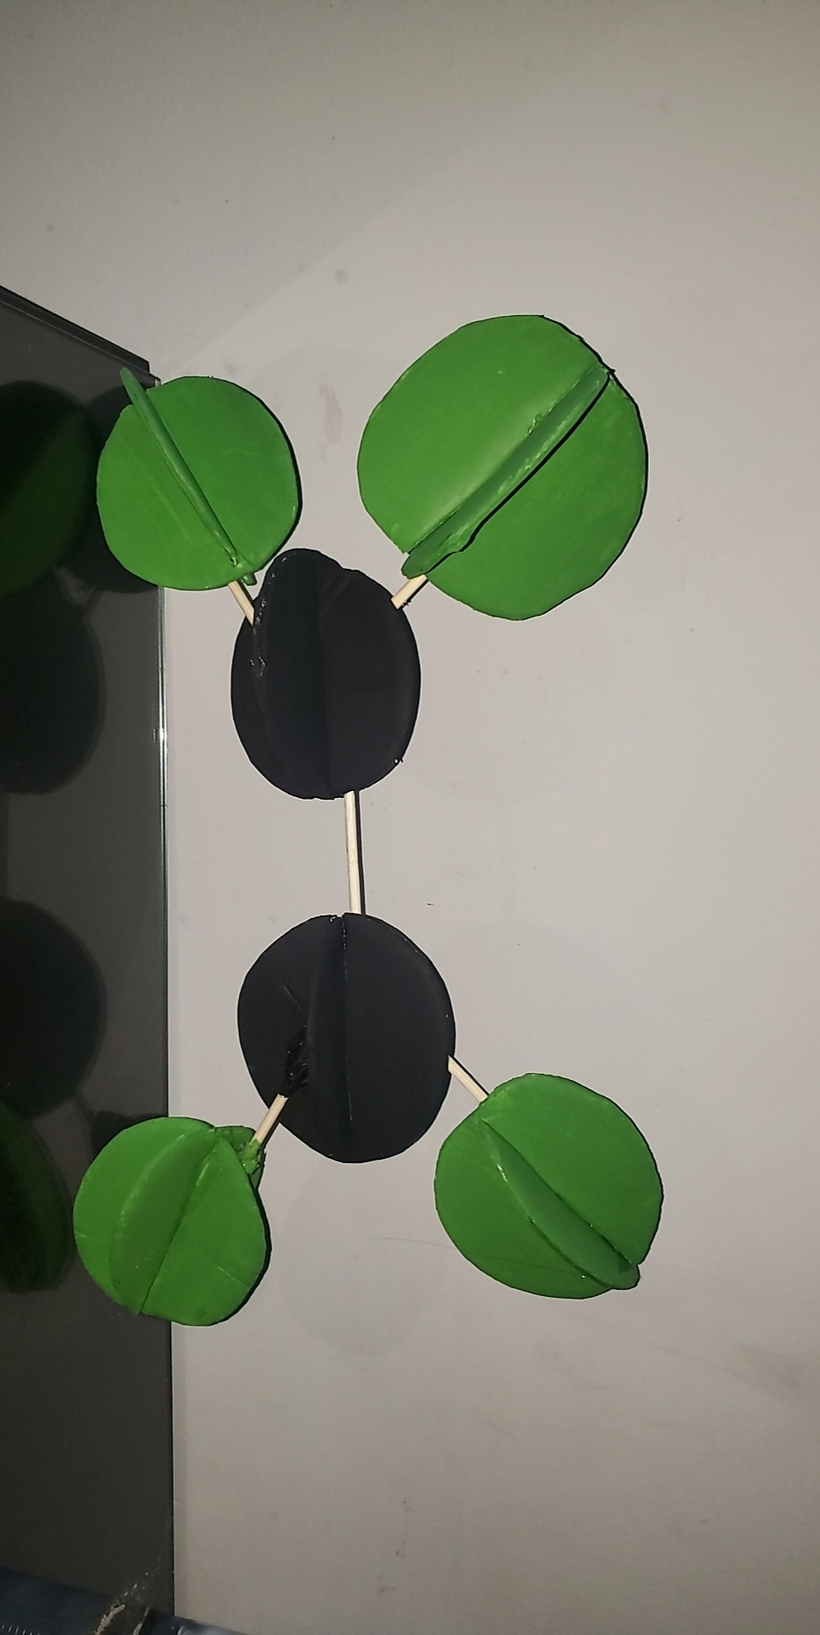

- Using an image of the structure (Above), state the shape around EACH 'central' atom (there may be many!) - basically all atoms except hydrogens.

- Include the hybridization around EACH ‘central’ atom?

- Polarity Analysis
  - Using electronegativity values/calculation and an explanation, determine the BOND polarity. Include bond dipoles (��⁺/��⁻) where appropriate.
  - Determine if the molecule is polar. Include the molecular dipole, if there is one. Explain fully, relating to your analysis from a.

- List at least 5 physical properties of the compound. For example, Molar mass, Appearance, Odor, Density, Melting point, Boiling point, Solubility (in water).

- Compare the boiling point of your compound to THE alkane (C_{x}H_{y}) that is closest in size ('close to the same' molar mass/# of electrons, ask me if you aren't sure) and explain any differences by discussing the intermolecular forces present for both molecules.

- Reactions involving your compound (Include a minimum of 3 reactions.)
- What reaction forms the compound (if there is one)?
- What reactions does this molecule undergo?
- Include complete structures and names for all reactants and products. Give the type of reaction for each.
- This should mostly come from your notes (organic reactions).

- Write the chemical equation for the combustion reaction of this compound. If you did this above, don’t re-do it just be sure all of the information below is included and perhaps put it on its own slide (or similar).

  - Include structures and names for all reactants and products.
  - Draw a potential energy diagram to show this reaction.
  - Find the enthalpy of combustion per mole of your compound using BOTH of the following methods;
    - Using bond energies
    - Using enthalpies of formation. **SHOW ALL WORK. These calculations should be clear and organized with point form explanations.
  - Compare these answers from c) and explain any differences. Which is more accurate and why? Add the more accurate value to your potential energy diagram drawn for b).

- If 10.0g of your compound is burned and used to heat 2.0L of water with an initial temperature of 20.0ºC, what is the final temperature of the water? Use the most accurate answer for the enthalpy of combustion from your calculations in #11.c.

- Since not all of these molecules are the same difficulty for orbital overlap diagrams, draw an orbital overlap diagrams for ethanal and ethanol. These are to be hand drawn. Be sure to label each orbital and each bond the way you have been taught. Finally, briefly explain why these molecules have such different bonding arrangements when their names and formulas are so similar.

- Concluding statements, reflections, or anything else you’d like to add. 4 sentences max. You may choose to omit this slide without deduction if you wish.

- Bibliography/Citations (Complete and in proper APA or MLA format)

